

**Brain**

**Drain**

**Higher Educational**

**Opportunity in the**

**City’s North-east**

**And The Case**

**for**

**Midland City**

**University**

**A Report**

**Commissioned**

**by The Friends of**

**Midland City**

**University**

**Inc.**

**Prepared by**

**Peter Vintila**

**Whether you work at a university, a corporate lab… or on a factory floor, the value you bring to the organization is in your head, rather than your hands, back or legs. The key to success, the competitive advantage, for a firm, a city or region lies in harnessing the knowledge and ideas of everybody and inventing new ways of doing things….. We humans – our minds and our ideas – are the most important factor of production of all.**

**Richard Florida, *Rise of the Creative Class*, Basic Books, New York, 2002.**

Copyright

Citizenonline 2005

**Table of Contents**

1. **Objective and Context of the Report**
2. **Key Recommendations: Our Ten Point Plan**
3. **Argument of the Report**
4. **20:20 and Beyond**
5. **Where Are We Now?**
6. **Lessons from the Past**
7. **A Tough *Act* to Follow**
8. **A Suitable Piece of Real Estate**

#### University Funding – the Shape of Things to Come

1. **Conclusions**

**Photo exhibits**

The photos reproduced in this Report do not relate to specific discussions or arguments. They relate, rather, to the spirit and purpose of the whole case made. They also reveal just a little of the treasure that is the Midland Railway Workshops Site. The value of that treasure has been best captured in an extensive report on the Midland Workshops' huge collection of machinery and plant prepared by C. and M. Doring – see extended quote on adjacent page.

Whether heritage centre development plans for the Midland Workshops realise the promise identified by the Dorings remains to be seen. While Friends of Midland University are concerned about this, our major interest – and the major interest of this Report lies elsewhere. We include the historical photos, however, for a number of reasons.

First, they hint at the treasures identified by the Doring Report and begin to illustrate the status which the Workshops could and, perhaps, should enjoy as ‘sacred site’. Yes, histories of WA demonstrate that the Work-shops were of immeasurable im-portance to the industrial development of WA as well as to its social and labour history. To call upon a famous precedent, one at least wants to say “Not too many merchants here please” - and our Report does.

A further question then arises: “Who can more properly occupy this ‘sacred’ precinct?” If one thinks of the creativity displayed, the determination and willingness to work demonstrated, the capacity to improvise and innovate shown, the scale and variety of learning undertaken, the stores of knowledge acquired and passed on by workers and managers alike… if one thinks of all of this, the answer is obvious…… ***Midland City University.***

**“… the Midland Workshops collection of equipment gives one of the most complete overviews of early to mid 20th century industrial engineering processes, which could not be found anywhere…. Midland Workshops has the potential to become an industrial museum of national or even international repute at which the public could watch manufacturing processes happening they could only read about elsewhere.…**

**Great industrial Museums in Germany Switzerland, the Science Museum in London and the Smithsonian in Washington DC all depend on static collections of disused machinery for their major displays. At the Powerhouse Museum in Sydney the opportunity for even a non-working display of historic powerhouse equipment was lost at the adaptation stage and this well known "Museum of Technology has only a meagre display of a few pieces of industrial machinery, unrelated to each other or to the building they are in.**

**At Ironbridge, the most famous industrial museum in the world, there is no working machinery on display.…. In contrast to the village scale and static displays of Ironbridge, Midland could give working demonstrations of metal moulding and casting, metal machining, manual and mechanical blacksmithing, mechanical woodworking, pattern making, hydraulic press forming, materials testing and so on using industrial scale machines in their genuine industrial settings…”**

*Midland Workshops Industrial Archaeological Study* prepared by C and M Doring and Associate, 1994.

**1. Objective and Context**

This aim of this Report is to build on the considerable momentum and community support that already exists for the development of university facilities in Midland. For the past 3 years, our small community organization has given a name to these facilities – ***Midland City University*** – not because we are wedded to a particular name, but because we are committed to a concept. That is to say, we are committed to the concept of a substantial, centrally located university presence in Midland accommodating 10,000 students by the year 2030. Whether that be an independent uni-versity or a “branch” campus of another university does not matter. Midland both needs and deserves a development of this kind.

The Report proper opens with a vision of Midland - ***20:20 and beyond -*** as a town transformed by the development of a university centred on the Railway Workshop Site over the next quarter century***.*** To be sure, this a vision and, according to the new Chairman of the Midland Redevelopment Authority, just idle fantasy. To this we say that some dreams, no matter how im-possible they may seem, are worth having. But, dreams and visions to one side, we also respectfully disagree with the new Chairman’s assessment of the real world. In truth, the development of a major university in Midland town over the 25 years – but beginning ***now*** - is a perfectly reasonable aspiration.

The title of this Report could not be more applicable than it is to the experience of Midland. In the year 2000 there were some 7,500 university students with home post codes in the Midland region. With the exception of perhaps 30 students in the coming year,[1] today’s students living in the Midland region all travel – or relocate - to the city’s western suburbs for their university education. Unless substan-tial university facilities are built in the City’s north-eastern quarter over the next 25 years, some 15 - 20,000[2] stud-ents could be travelling to the west for their higher education. That is ***brain draining*** on a shameless scale and the map shown overleaf demonstrates, at a glance, how and why this might happen. Some accompanying statistics are also worth citing immediately.

Regional comparisons are shown in the Box below. The west is much better off than the east as whole. But young people living in the local government areas enjoying beachfront or Swan River foreshore – “the first eleven” – not only have easier access to sail, surf and sun but also to study. By the measure used below, they are ***1250 times*** better offthan their poorer eastern cousins in terms of access to university. As the figures indicate, these localities form a region of ***higher educational superabundance, hosting an astonishing 1 university place per 4 head of population.*** The correspond-ing figure for the west as whole is ***1 per 50*** while that for the east is ***1 per 5,000.***

###### **University places per 1,000 head of population in metropolitan Perth**

**Eastern Suburbs**

**(LGAs east of CBD) 0.2**

**Western Suburbs**

**(LGAs west of CBD) 50.0**

**“First Eleven”**

**(central and inner Western LGAs**

**enjoying beach front and**

**Swan River foreshore)** **250.0**

Note: Table relates to the year 2000. For data sources and definition of regions see citizenonline.org

In the context of higher eduction, “brain draining” brings with it other important losses. Thus, full time stud-ents are worth roughly $20,000[3] pa in terms of the money they spend on tuition and living costs. In Midland today this amounts to some $150 mil-lion. Most of this money could circ-ulate productively in Midland’s local and regional economies for some time – if there were a university operating on a sufficient scale. In the absence of substantial facilities, the regional fin-ancial drain could well reach $400 million pa in 25 years.

**Current unequal treatment**

Three of Perth’s public universities enjoyed substantial original land grants of 1600 ha (UWA), 260 ha (Murdoch) and 80 ha (Curtin). It is it true that some of the advantages enjoyed by the west in this regard reflect history – especially in the case of UWA which received its original land grants a century ago.

But historical factors do not tell the whole story. For example, Edith Cowan University (ECU) services a regional population of about 136,000 of whom some 4,400[4] are university students. Today these students can compete for some 6,000 regional places. Midland now has about ***one half of one percent*** as many – perhaps 30 actual places. And this is to service a regional population and a regional university student population which are both around ***twice as high***as those to the City’s north: 271,000 and 7,600 respectively. Against this background, ECU is currently selling land granted to it by the State Government and anticipates a $40 million profit.

Why can’t Midland make a comparable claim and be taken seriously? Do the relevant authorities think that people in Midland can’t do basic arithmetic or make simple comparisons? Is that why they resist the claim for a university?

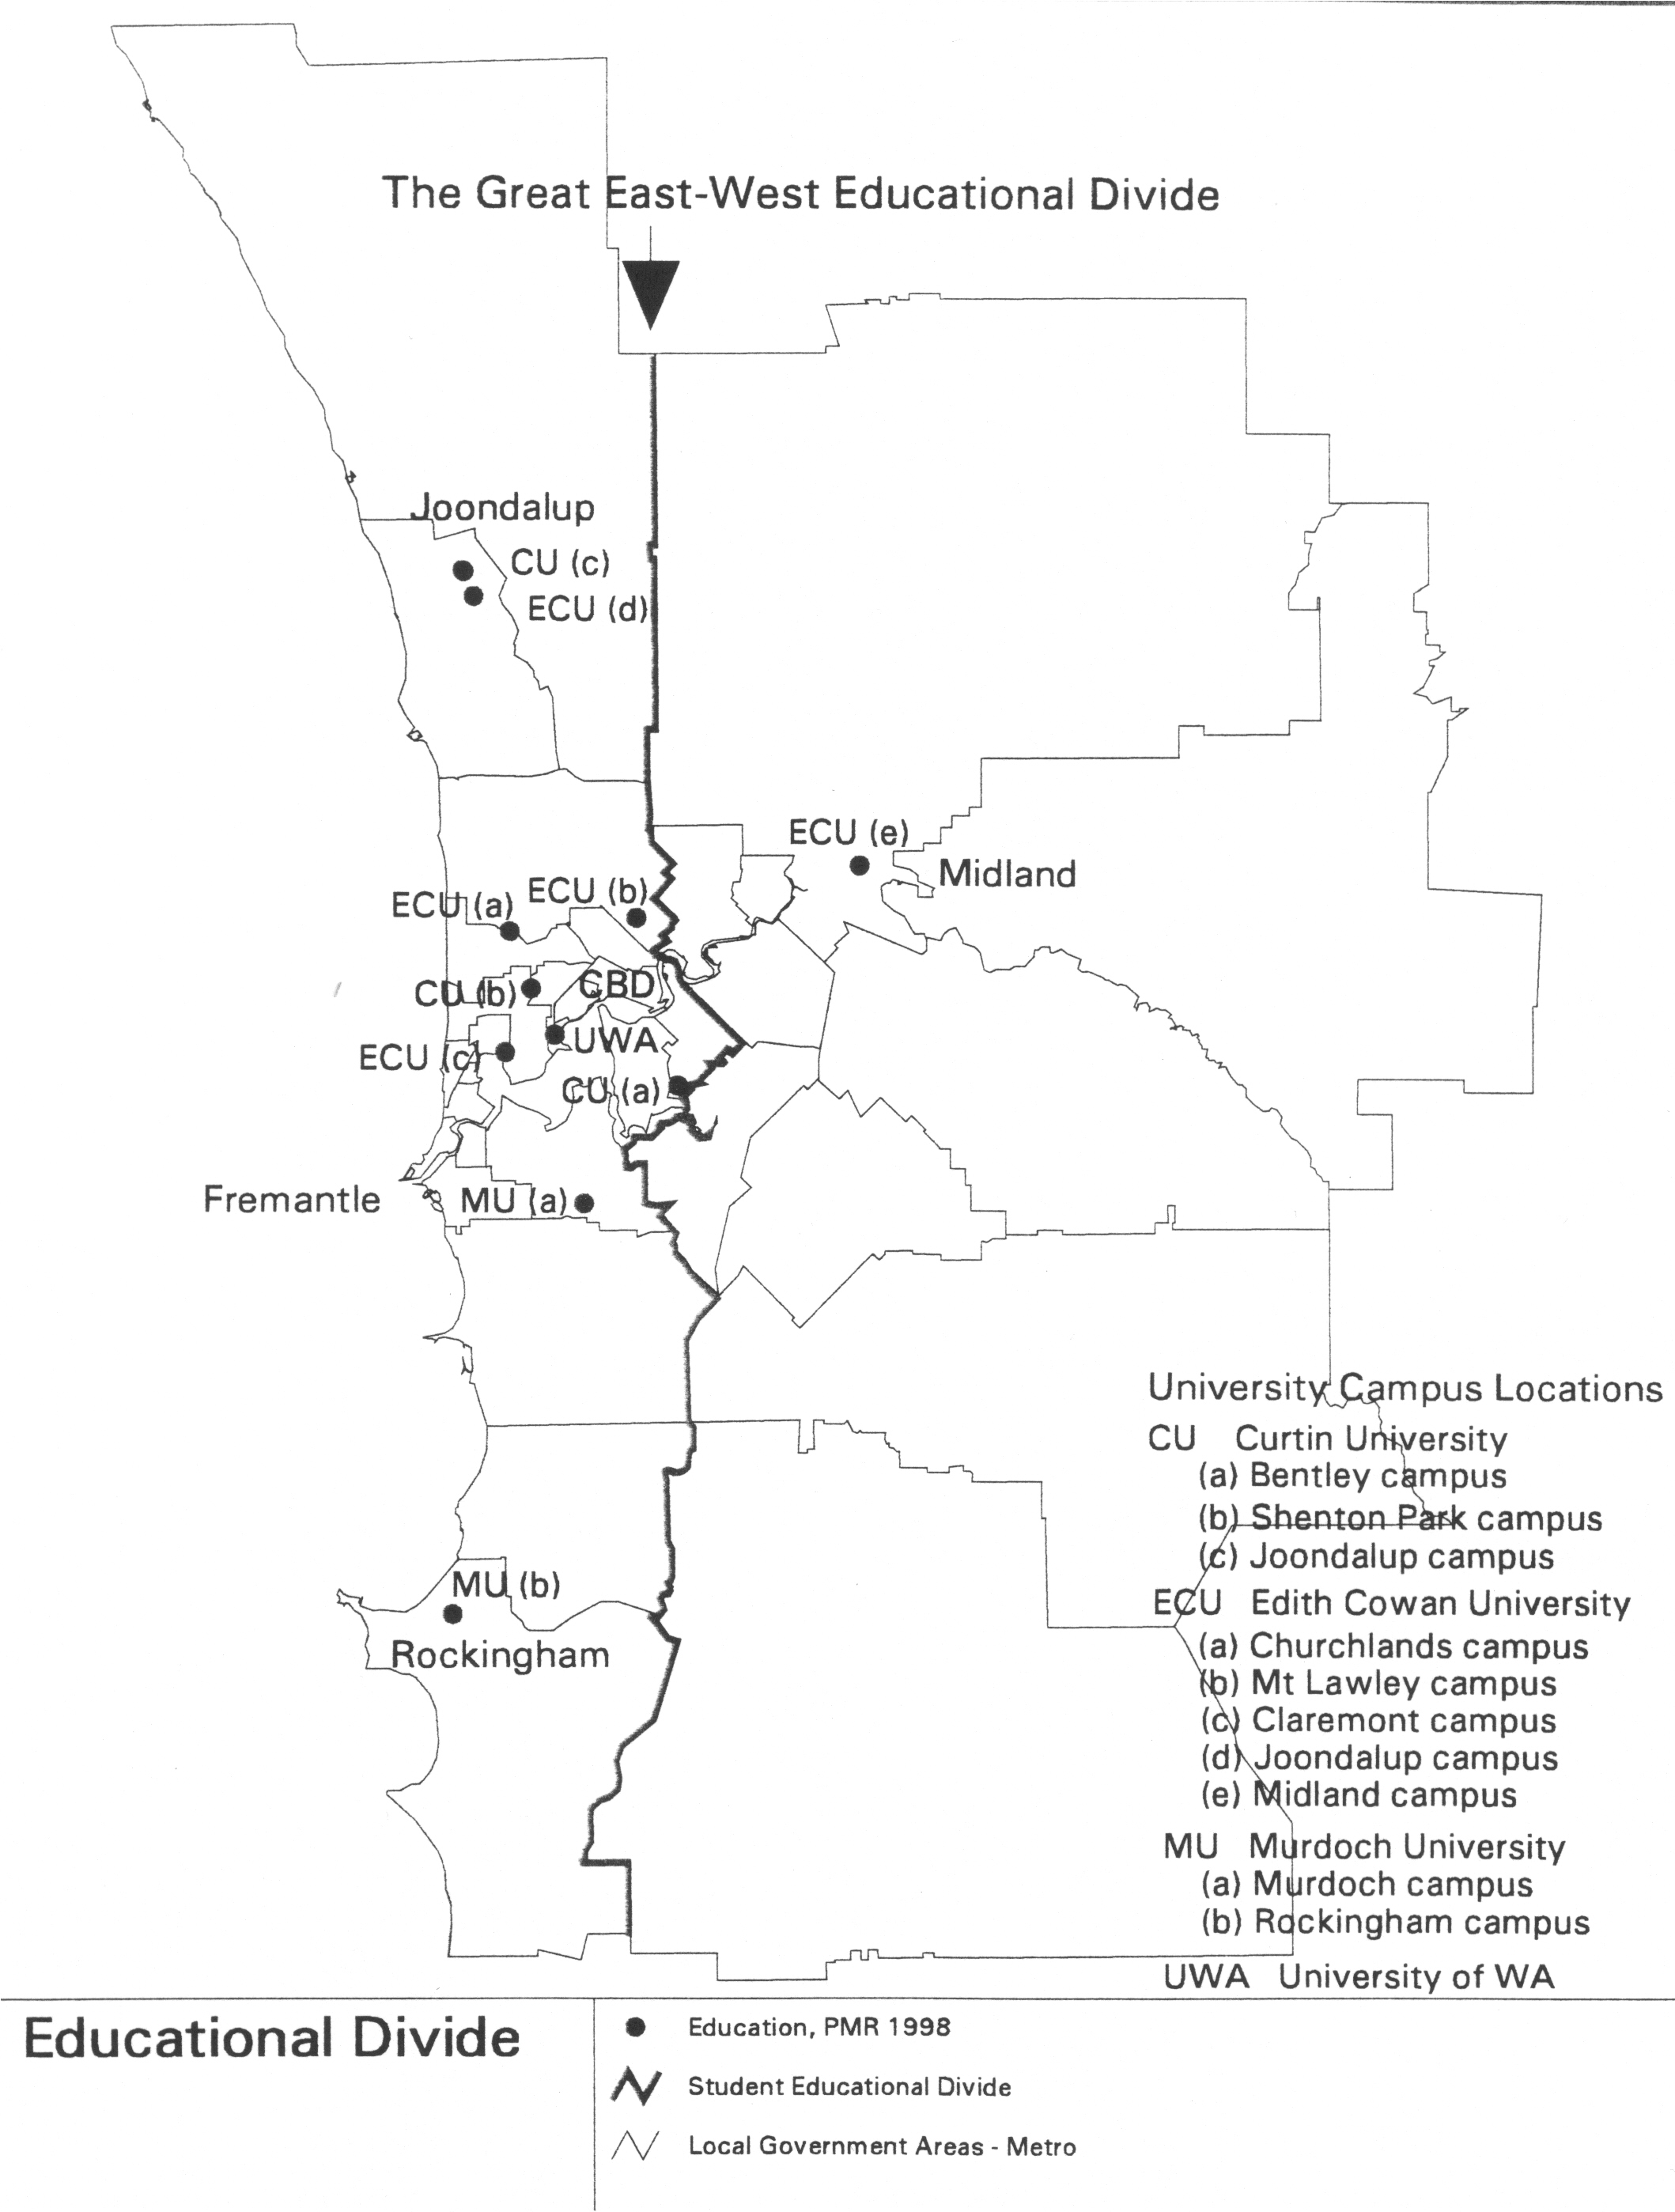

#### Table 1 Perth’s Population, University Places and University Students by Urban Location

|  |  |  |  |
| --- | --- | --- | --- |
|  | Population | University Places | University Students |
| Western Suburbs | 886,334 | 45,841 | 33,808 |
| Eastern Suburbs | 474,882 | 98 | 13,131 |
| Total Perth | 1,361,,216 | 46,939 | 46,939 |

Sources: ABS, UWA Curtin Murdoch and Edith Cowan Universities (data for years 2000-01).

**2. Key recommendations – Our Ten Point Plan**

The State Government should:

1. **guarantee** the availability of suff-icient land on the Midland Railway Workshop Site for the long term future higher educational needs of Midland;
2. **amend** the *Midland Redevelop-ment Act* so that it enshrines a commitment to a Midland Higher Education Precinct (incorporating a a strong university presence) in legislation;

1. **establish** a new Management Board for the Midland Redev-elopment Authority (MRA) that brings together expertise and experience relevant to the amended *Act;*
2. **direct** the Board to develop a 20-25 year strategic redevelopment plan based on a clear vision of the region’s future and a well re-searched understanding of its future higher educational needs;
3. **establish** an expanded and appropriately qualified Executive and provide the new Board and Executive with an adequate work-ing budget – not just loans which force premature land sales;
4. **direct** the Board to develop a strat-egic plan that provides for in-tegrated senior high school, tech-nical and university education;
5. **direct** the Board to develop a strategic plan integrating heritage, secondary, technical and higher educational uses in order to max-imise community access, potential for innovation and institutional synergy;
6. **ensure** that current community and education initiatives relating to heritage and higher education take their place within the framework of a long term planning and dis-courage ad hoc initiatives;
7. **order** a review of the original financial modelling and forecasting conducted by the MRA in order to plan its redevelopment work;
8. **encourage** the State’s existing universities to develop an “industry plan” which incorporates a clear social charter and which refers to the higher educational needs and reasonable expectations of all people in WA.

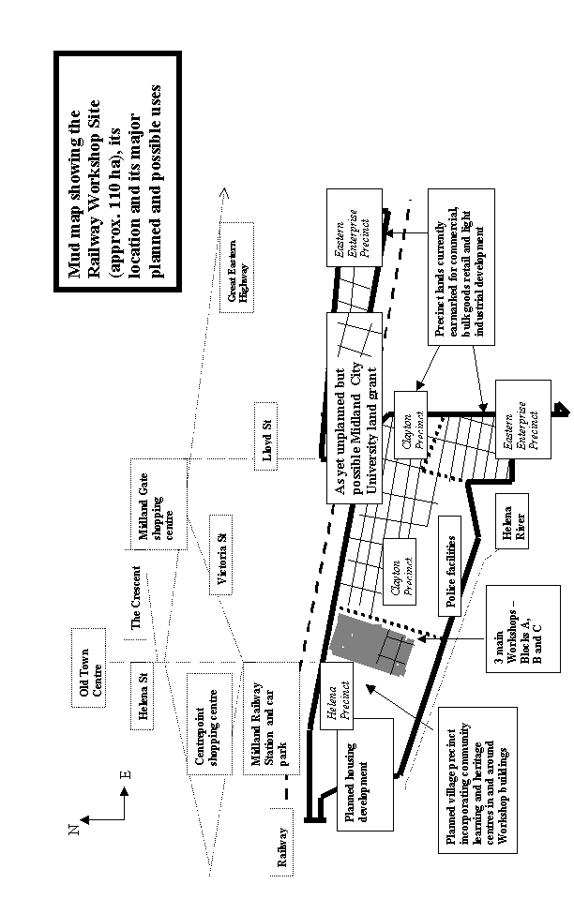**3. Argument in brief**

As with universities anywhere, the de-velopment of a university in Midland in coming decades depends on the following requirements:

* qualified students;
* suitably located land;
* money; and
* political will.

As the brief discussion below will indicate, these requirements, with the exception of the last, can be met without great difficulty in Midland.

#### Students

Today there are at least 7,500 uni-versity students in the Midland region and this number could well grow to 20,000 over the next 20 years. If just half of these students chose to study closer to home, a 10,000 student Midland campus would be filled. And this does not count students who might travel to Midland from elsewhere in the metro area – or come as overseas students. This evidence is explored in Section 5 of the Report – ***Where are we now?*** In short, the demand for a very substantial higher education precinct with a university presence as its backbone will certainly be there by 2030.

#### Land

The land is also there – 110 or so ha owned by the Midland Development Authority (MRA). This land is centred on the Railway Workshop Site, abuts Midland’s railway station and is within walking distance of the city centre. In short, its location is fantastic and it is cheap as well - around $100 per square metre when cleaned up and serviced.[5]

Of course matters are not quite so simple. The MRA has plans for site. Some of these are good - including plans for the western portion of the site or the Helena Precinct - but remain incomplete.[6] Others are not so good. And here we are principally talking about plans for most of the 40 or so usable hectares of land to the east of the Helena Precinct. These plans ded-icate land to substantial commercial, bulk goods retail and light industrial development.[7]

Current plans for the eastern end of the site are poor for a number of reasons. They are unlikely to contribute to the MRA’s self-assumed objectives such as “leading the revitalisation of Midland”. More specifically, they do not sit well with plans for the western half of the site or old town centre. The old town centre does not need competing commercial development – especially when plans are afoot for the massive redevelopment of the railway car park and Centrepoint sites. And it needs more bulk goods retail and light industrial capacity on its threshold even less - especially when these car-intensive forms of development are placed in a rail corridor.

This is poor planning at the best of times. In an era desperate to reduce greenhouse emissions it is downright irresponsible. Midland will not be-come a vibrant and attractive 21st regional city or economic driver in this way.The MRA’s plans commit too much land to uses which are economically sterile, which discourage street life, which degrade urban space and which squander opportunities for enhanced sustainability - more bulk goods retail and more light industrial development. It hardly seems credible that anyone, other than the bulk goods retail sector, believes that Midland needs more of these facilities so close to town.

It is true that part of the MRA’s plans for the site’s western end, including its huge heritage buildings, involve a “community education centre” built largely around high school and TAFE teaching facilities. But early plans for this centre remain tentative and, in any event, contain no provision for a significant university presence now or in the future.

The arguments outlined above are principally developed in Sections 6, 7 and 8 of the Report. Section 6 - ***Lessons from the past* -** comments briefly on the State Government’s historic role in granting land to the city’s existing universities focussing variously on the timing, scale and importance of those grants. Section 7 - ***A tough Act to follow*** – argues that the MRA’s poor planning decisions and its failure to take a serious interest in higher education planning are prin-cipally a function of its limited charter - the *Midland Redevelopment Act.*

Having said that, the vacant land is still there. At this point in time, only poor and reversible planning decisions stand between the land and its availability. However, in due course actual development driven by poor plans could change this. Opportunities could be lost. Section 8 of the Report - ***A suitable piece of real estate*[8]**  – high- lights the importance of prudence in this context. The immediate challenge is simply to avoid squandering opportunities not likely to last forever.

#### Money

Key funding issues are discussed in Section 9 of the Report ***(University funding- the shape of things to come).*** Here the Report basically argues that objections to new university de-velopment based on the unavailability of funds are either ill-considered or outdated. They are ill-considered be-cause the University sector will continue to grow in forthcoming decades – perhaps doubling over the next 25 years.[9] There is, therefore, no question about the need for new capacity. The outstanding question here is not “whether”, but “where” to build new capacity. And of course we should ask here: Will new capacity in Perth, add to superabundance in the west or will it make good almost total neglect in the east?

**Demand for university places may double in the next 25 years across Australia – requiring lots of new capacity. Why shouldn’t some of this capacity be planned and built in Midland?**

The argument is out of date because, in one way or another, students are be-coming “higher education customers” and are or will become self-funding. They are being called upon to save or borrow more but even where gov-ernment grants continue to provide subsidy, these granted funds are increasingly conceptualised and con-structed as individual student assets or income – for which universities must compete. Thus students become customers and, for better or worse, market disciplines are imposed on universities.

More to the point, when students queue up at the university’s gate, they are cashed up and ready to go. Considered within the framework of this bigger picture, the “no money” argument is a hoax. Students in Midland already have the money to pay for a university in Midland. Thus the 10,000 students who may elect to study in Midland in 25 years time would be paying some $100 million pa to Midland City University.

**Would $100 million be enough to run Midland City University? If higher education has been properly costed by the financial experts, it must be. But a rough and ready reality check is possible. Murdoch University currently provides tuition to its 13,000 students for less than $130 million pa. Midland is in the ball park.**

This argument does not mean that there is no financing challenge. The real nature of that challenge, however, is different from the manner in which it is usually presented: it is not a matter of finding money to maintain a university in Midland. It is a matter of finding the political courage necessary to change a long standing arrangement which forces university students to leave Midland with their money – to the great disadvantage of many of those students and to the perhaps greater disadvantage of the Midland region. This Report, again, estimates, that in 25 years time, Midland’s 20,000 university students will be taking around $400 million pa out of the local economy as they travel and spend “abroad” for their higher education – a level of investment sufficient for about 8,000 full time jobs.

#### Political will

What can the State Government do to change things. In short, it needs to reverse an ill considered decision which is committing a tract of urban land to unspecified bulk goods retail, commercial and light industrial uses. And it needs to reserve that land for future higher education and university development instead. When the time is right, the Government needs to vest this land in a higher education planning body (Why not the Midland City University Planning Group). This should certainly happen within the term of the next State Government.

If it turns out that no capital funds from traditional public sources can be found, then an entrepreneurial planning board should be authorised to seek out lenders, private investors and joint venturers willing to invest com-mercially in a growth industry. Erect your buildings, plant your gardens, hire your staff…. and there’s your university. After that, student fees calculated on a full-cost recovery basis keep it going. Hopefully, too, HECS loans and public subsidies will still be kicking in so that poorer students are not ruled out. Any Commonwealth policy decisions of this kind will hit the Midland region hard.

The existing universities may not like having some of their future business diverted in this way - and this is the real test of political will. But the State Government should firmly and politely invite them either to set up shop in Midland or mind their own businesses. It is not the State Government’s first responsibility to make life easier for large commercialising and corporat-ising institutions at the expense of disadvantaged students and regions – or at least one would hope not.

This final point should have traction with both major political parties, even if they once had different moral vocabularies to address such problems. For the Labor Party, the situation should still be recognisable as simple injustice (easy access to universities for some – the relatively affluent - and difficult access for others – the relatively poor) while for the Liberals the problem turns on the improper restriction of competition and abuse of market power. Either way State Gov-ernments should not aid and abet here.

**4. 20:20 and beyond**

### 2000 - A Portrait of Decline

At the northern end of Midland’s once proud and vibrant main street - the beautifully named Helena Street - stands a complex of shiny new multi-storey offices accommodating government guest workers from 9.00 am to 5.00 pm each week day. They provide trade for a few smarter lunchtime cafes and the refurbished Council Club. Otherwise the insubstantial presence of these workers demonstrates how hard it is to revive old town centres suffering from the ravages of time, industrial decline and an out-of-town shopping mall - Midland Gate.

The rest of Helena Street hosts less-than-chic real estate offices, accounting firms, solicitors’ rooms and professional medical suites. A local MP makes a symbolic show of loyalty and a few retailers of new and discounted wares are also toughing it out. But even King Kong, that discounter of all discounters, has left the old city centre and attached itself to Midland Gate’s more bounteous skirts. The rest of the stayers include second hand clothing and furniture shops, a security firm, short term money lenders, martial arts trainers, a petrol station, an “adult” shop and brothel and a down-at-heel car rental business. In any thriving town, many of these businesses would have backstreet addresses. To its southern end Helena Street hosts an older, smaller shopping mall - Centrepoint – which turns a blank windowless face to the street. Finally, opposite this blank windowless face stands a weary railway terminal and bus interchange.

To complete the picture of urban decline, the whole of the Helena Street strip is frequently punctuated by the sorry display of permanently padlocked doors, blanked out shop fronts and darkened, dusty arcades. There is more – or should I say, there will soon be less. Just around corner from Helena St, Midland hosts a small twin theatre cinema complex – the Regent. The Regent is likely to collapse if Midland Gate develops its planned 8 theatre strong complex.

Whether intentionally or not, the proprietors of Midland Gate – encouraged by the town’s planners - are creating a new town centre. As this report goes to press they are expanding their mall even though it is clear that Midland cannot, as things stand, support two centres. The old town needs something new.

**Beyond 2020 – A Picture of Revival**

Today Midland is a bustling town and reinvigorated regional centre. The old town is no longer as it was 25 years ago: often sluggish by day; moribund and sometimes dangerous by night. It has undergone a transformation – not unlike the transformation that overtook Fremantle in the last quarter of the 20th century. But also different.

Like Fremantle following its transformation, Midland pulses with both daytime and night-time life. Its major artery - its South Terrace - is Helena Street. And like South Terrace, Helena Street caters for the new knowledge workers and aspiring knowledge workers crowding its expanded pedestrian zones. Gone are the low rent uses of yesteryear and in their place one finds busy internet cafes now serving not just as email stations but as street front research facilities and digital news outlets offering global connections in real time. For old print junkies, there are new and second hand bookshops and news agencies still selling ink on paper. Last, but far from least, Helena Street now also hosts the predictable super-abundance of thriving coffee shops, tea houses, wine and boutique beer bars, fast food outlets and restaurants serving multicultural fare 7 days a week and long into the night.

Filled to its brim, Helena Street’s good fortune is now overflowing into the network of side streets surrounding it – but not all of this can be described in this briefest of portraits. Only perhaps the restored Regent Cinema complex, still just around the corner, should be mentioned. It was restored a few years ago when purchased by the rapidly expanding Midland City University. The Regent now rivals Perth’s most successful art-house cinemas and its screening facilities showcase experimental community and student film and television productions. This work and the Swan School of Film and Television from which it comes are also part of Midland City University located just a few hundred metres down Helena street in the old Midland Railway Workshop site. The Swan School of Film and Television and the huge unencumbered space it occupies in a main Workshop shed make it the envy of every media production studio in the country. How has all of this come to pass?

In the course of the last 25 years, Midland, old Midland, has become a university town and the knowledge economy is seriously taking root. Aspiring and accomplished knowledge workers alike are increasingly deciding to live and play in the place in which they work. As they do so, they are not just laying foundations for tomorrow. They are also generating new businesses and business opportunities of all kinds today. They are filling Helena Street and its tributaries with varied economic activity and a diverse cultural life. This means jobs and it also creates a necessary part of the milieu in which high-end knowledge economy work flourishes.

Racially and ethnically, the streets have that rich new global cosmopolitan feel. Midland’s innovative teaching and research programs are attracting overseas students in increasing numbers. More significantly, perhaps, Midland also now has the highest proportion of indigenous university students in the whole of Australia.

In the early years when the University and larger precinct of which it is now the centrepiece were little more than a dream, very few believed it could happen. The turning point came in 2005 when the then State Government took steps to amend *the Midland Redevelopment Act* and overhaul the Midland Redevelopment Authority. Also, in a rare moment of bipartisanship, the Opposition sup-ported these changes. The rest, as they say, is now history.

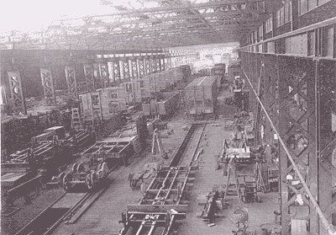

general view of wagon shop

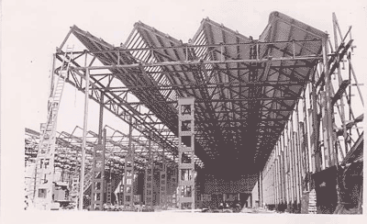

#### construction of the shell annexe

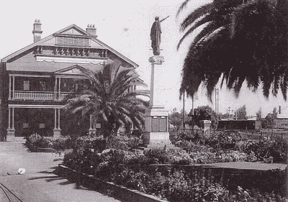

**chief engineer’s office and peace memorial**

**5. Where are we now?**

Three years ago, Friends of Midland University published a paper on its website (www. citizenonline.org). The paper, entitled *Knowledge Rich; Knowledge Poor*,[10] investigated the distribution of opportunities for higher learning in metropolitan Perth. The investigation revealed staggering differences between the city’s eastern and western regions: while the city’s western side provided one university place per 20 head of population, the eastern side enjoyed the benefit of just one place per 5,000. Following the recent closure of Edith Cowan’s (ECU) tiny facility in Midland, however, there are now less places still in the east.

Commenting on the closure of the ECU Midland facility late last year, ECU’s Vice Chancellor ventured the following consolation:

We believe major campuses provide much richer experiences for students.

Friends of Midland City University could not agree more with the Vice Chancellor. We, however, draw a very different conclusion. Our conclusion is not that Midland is better off with nothing. We conclude, rather, that Midland needs ***its own major campus***– one commensurate with current and future local demand. The numbers here, are striking as well. In the year 2000, the Midland region was home to some 7,500 students.[11] And by 2025 this number will double and perhaps even grow to 20,000.[12] Additionally, a major campus in Midland could well also capture a significant proportion of what may by then be a large number of overseas students studying in Perth.[13]

A new Midland University or university campus does not have to be a clone of our existing universities. Indeed, a new university in Midland will offer great scope for innovation. But whatever else it may be or become, higher education development in Midland needs to be pursued as a substantial and serious undertaking. Its scale, again, needs to provide a reasonable response to growing regional demand. It also needs to be able to confer real and competitive degrees in quantities and varieties matching the region’s economic, social and cultural aspirations. As for teaching and research agendas, these should be planned in a manner that gives real voice to local industry and community interests.

**Higher education in Midland needs to be pursued as a serious undertaking. Its scale needs to provide a reasonable response to growing regional demand. It also needs to be able to confer real and competitive degrees in quantities and varieties matching the region’s economic, social and cultural aspirations.**

It will certainly not be possible to start building these facilities next year or even in the next three or four years. But given demand forecasts, it will become increasingly important to begin serious building in five or six years time. For this to happen, however, strategic planning and

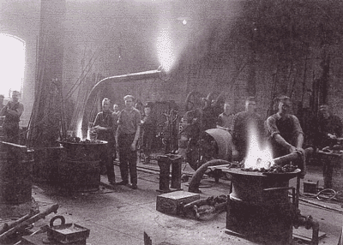

#### brazing flanges

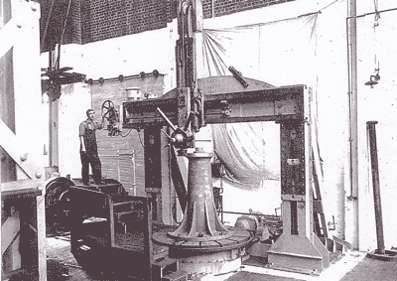

**boring machine designed built by workshops**

serious land reservation must begin now.

Much of the argument developed in the balance of this Report addresses these two issues:

* the immediate need for serious strategic planning **-** planning which is firmly anchored in long term demand forecasts and careful social and economic impact assessments;
* the need for serious land reservation.

Land reservation, furthermore, needs to focus principally on the Midland Railway workshops site - for land better suited to the development of higher education facilities is hardly imaginable (see **Box 1**).

**Box 1 The Midland Railway Workshop Site**

**The Midland Railway Workshop site, now controlled by the Midland Redevelopment Authority, encompasses a large tract (some 80 hectares) of inner urban land. The site adjoins the Midland town centre and envelops a major railway station and bus terminal. The site also contains a breathtaking collection of heritage buildings and industrial artefacts. Never has a site lent itself more perfectly to rehabilitation and re-use as a higher educational precinct and university campus. There are extraordinary and extraordinarily large buildings to be restored and re-used. The site is perfectly located to accommodate new educational buildings and facilities – again it abuts a town centre and it offers far better public transport connections than any of Perth’s other campuses. Finally, the site is substantial, offering room for new building, for open space and for complementary uses.**

The need for 25 year planning horizons will not be obvious to all. As indicated in the following section of this Report, however, some 10 years separated the *University Endowment Act* of 1904[14] and the establishment of the University of Western Australia (UWA). Almost another 10 years went by before UWA actually moved – in 1923 - to the Crawley site it now occupies. Working within timeframes so scaled is simply the intelligent thing to do when planning such expensive and strategically important social infrastructure. Those who pioneered the development of higher education in WA a century ago understood this very well indeed.

#### Planning for higher education in Midland needs to be not just strategic and long term. It also needs to be cast in strong ethical and social justice terms. And it needs to be supported by hard empirical evidence. Tough, ethically and empirically informed argument limits opportunities for ill-defined commitment, for vague political promises and for bureaucratic prevarication. It is the responsibility of those campaigning seriously for higher education facilities in Midland today to limit these opportunities and to extract clear and firm undertakings. It is a major aim of this Report to contribute to these ends.

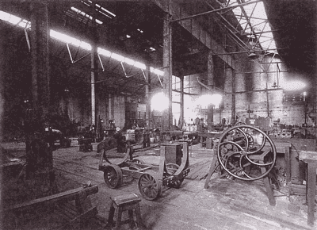

general view coppersmith shop

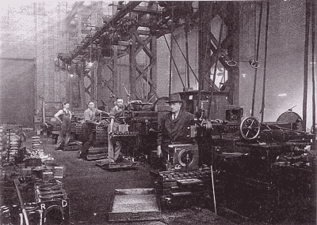

**shaper machines**

**6. Lessons from the past**

For the first decade of its life, the University of Western Australia was housed in temporary accommodation in Irwin Street in the Perth City centre. Only in 1923 did the young University move to the magnificent Crawley site on the Swan River foreshore at Matilda Bay. This site, as we all know, would become the University’s permanent home. It encompassed some 67 ha and, today, this may strike us as a very generous land grant given the tiny size of the University in its early days.

It is important to remember, however, that State Governments at the time were moved by genuinely long term visions and unconstrained by impatient development imperatives. As Professor Fred Alexander has made clear in his history of UWA, they had a real commitment to the future growth of the State’s higher education capacity. The now often glib language of the knowledge economy may have been foreign to them, but their thinking was ahead of its time. Just what we want of our higher education planners.

Nor was the 67-hectare Crawley site all. Indeed, it was just a small part of a parcel of endowment lands extending to almost 1600 hectares. This land was set aside by the *University Endowment Act* of 1904 when the University was little more than an idea. Land was the most useful and durable resource that the State could make available to an infant institution of higher learning. Provided that it was of sufficient quantity and quality, land could accommodate institutional growth long into the future. It was also able to serve as a flexible and continually appreciating asset that could be sold, swapped, used to secure borrowing or just rented out.

It is impossible to overestimate the wise and farsighted nature of these public land grants and it is worth dwelling on their consequences a little longer. Firstly, those taking charge of the land were not subjected to any pressures to develop quickly – let alone turn a profit. Nor, while they attended to the growth of their new institution, were they required to face competition from rival development proposals or pressure from a State Treasury anxious about its credit rating. No, they were effectively given the land and were allowed to get on with the job of developing the State’s capacity for higher education. This task was challenging enough and everyone, again, understood that patience and long-term development horizons were necessary.

Though much less generous than UWA’s endowments, Perth’s other public universities have also received significant grants of public land. The principal campuses of Murdoch and Curtin Universities are 260 hectares and 80 hectares respectively. Edith Cowan, as an amalgamation of the State’s former Colleges of Advanced Education, enjoys secure leases over a number of former CAE campuses. Additionally, it has recently acquired one of these campuses (Churchlands) outright and will sell it to finance consolidation and capital works at Joondalup. Recent newspaper reports have assigned a net value of $40 million to this site. Yet in Midland today, this seems too much too ask The Chairman of the MRA dismisses a comparable claim in Midland as fanciful. We still need to ask him why.

In Midland today, inner urban land that might be reserved for university de-velopment at very low cost[15] is currently destined to accommodate bulk retail and light industrial facil-ities. A third – or perhaps more - of the total Workshop Site and its ad-joining publicly owned land is ear-marked for these low-grade uses. Given the size (and value) of Perth’s other university campuses, reserving this land for future university de-velopment in Midland is hardly a lot to ask. After all, which is Midland likely to have a greater need for in the decades immediately ahead – more bed sheds and barbeques galore? Or more of the highest kinds of learning that make for genuinely sustainable eco-nomic and social development?

In overall terms, the State has clearly invested in higher education and in the knowledge economy – but that investment, as the **table and map** below show, is not very fair.

.

**The Chairman of the MRA has dismissed Midland’s claim for equitable treatment in terms of university land grants as fanciful. He has still not explained himself.**

What is Midland likely to need more urgently in the decades immediately ahead? More bed sheds and barbeques galore? Or more of the highest kinds of learning that make for genuinely sustainable economic and social development.

# **Table 1: Unequal access to higher education**

|  |  |  |  |  |
| --- | --- | --- | --- | --- |
|  | **Central catchment** | **Joondalup catchment** | **Rockingham catchment** | **Midland catchment** |
| Population | 649,100 | 136,400 | 258,600 | 270,900 |
| University students | 30,200 | 4,400 | 5,000 | 7,600 |
| University participation rates | 4.7% | 3.2% | 1.9% | 2.8% |
| University places | 42,100 | 4,200 | 550 | 100 |
| University places per 1,000 head of population | 66.7 | 31.3 | 2.1 | 0.4 |
| Homeswest rentals as % of all rentals | 16.9% | 7.8% | 22.1% | 21.4% |

Notes: Table relates to the year 2000. For data sources and definition of regions, see citizenonline.org (maps and graphics). Today, as a result of the ECU campus closure, Midland’s university places are probably down by 50% on the above figures. **See Map to accompany table and define catchments on the following page.**

Row 5 provides a population weighted measure – university places per 1,000 head of population – and is the most telling. Values range from 66.7 to 0.4. In other words, inner and inner western Perth enjoy a level of provision which is around 170 times more generous than Midland or north-eastern Perth. Even Rockingham, which hosts only very limited facilities, is 5 times better-off than Midland. Links between university provision and academic performance (measured as university participation rates) and social dis-advantage (measured as Homeswest rentals) are also significant.

Overall, the inequalities revealed in the table above are becoming more apparent to communities in the Midland region. But the State Government appears reluctant to remedy them. The rhetoric is certainly there. Thus, State Education Minister Alan Carpenter has recently referred to the idea of an education or community learning precinct as an “exciting visionary concept” while local MLA and Minister for Police, Michelle Roberts, has, in the same spirit, declared that “Midland could provide a phenomenal hub for learning.” [16]

So far, however, the concept planning is based almost solely on secondary and TAFE facilities. And these, Midland has already. To be sure, relocating some of these facilities to the Workshop site could result in important new developments and improvements – but, in the final analysis, relocated facilities are not new facilities. What would be genuinely new in the Midland region, what would really be “exciting and visionary”, and what would make for a truly “phenomenal learning hub” is a community learning centre based on a strong and innovative university pre-sence. So far, sadly, no such presence figures in the plans.

In an unexpected turn of events, the Commonwealth Government, in the person of Brendan Nelson, Federal Minister for Education, has promised Midland 20 full time places through Curtin University. It is difficult to know whether this was more than one-off impulsive gesture at a celebrity breakfast intended to generate political capital – but it makes for a significantly smaller university presence than that provided by Edith Cowan in its failed experiment on the Railway Workshop Site. However one interprets this gesture, it puts the ball squarely in the State Government’s court.

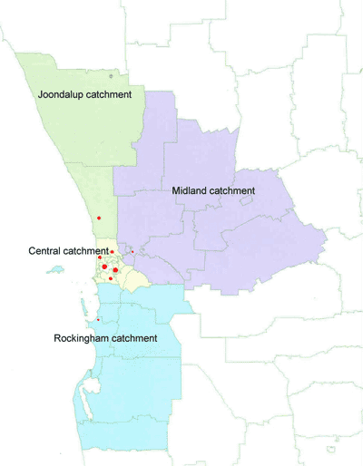

So why is it hesitating. Why would it prefer to see yet further light industrial and bulk retail development in close proximity to the Midland town centre than a university campus? One or two simple reasons are worth briefly exploring. The Midland region suffers from forms of social disadvantage (see ***Box 2*** below) that can distort regional public investment decisions. Social disadvantage can limit lobbying power, diminish influence and generate stigma. Poorer people often tend to be less skilled at organising themselves. It is also still widely believed that poorer people deserve their disadvantage and wealthier people their privileges – because they are more clever and hardworking. And this applies even to their publicly funded privileges - like universities.

The continuing build up of major university facilities in Perth’s northern region provides these arguments with spectacular evidence. Edith Cowan University is now establishing itself in Joondalup to service the city’s northern corridor. The population it services in that region is about 136,000, the number of enrolled university students living in the region is around 4,400 and the number of university places locally available to them is around 6,000.

Midland, by contrast, has about **one percent** as many places – perhaps 30[17]. And this is to service a regional population and regional university student population which are both around twice as high as those to the City’s north. The figures for Midland in Table 1 show are 271,000 and 7,600 respectively. Why is one region treated so well and the other so grudgingly? And why do we live with this as though it was God’s plan –part of a divinely ordained scheme of things?

## Box 2. Educational and Social Disadvantage

**In 2004, the *West Australian* published results from an ABS analysis of 2001 census data identifying Perth’s ten most and least disadvantaged suburbs.**

**Four of the ten most disadvantaged were located in the immediate vicinity of Midland – including Midland itself. Another four were to be found on the edge of the larger Midland region (ie Perth’s north eastern metropolitan quarter).**

**All of the most advantaged suburbs were, to no-one’s surprise, located in the city’s inner western zone. There they formed – and this is more surprising - part of a region of higher educational superabundance, hosting an astonishing 1 university place per 4 head of population.This figure should be compared with those indicated by Table 1 above.**

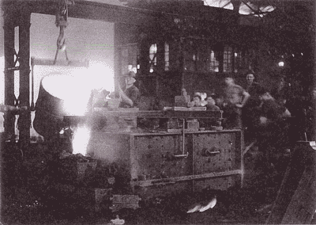

##### pouring castings

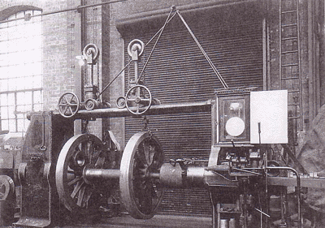

**wheel press**

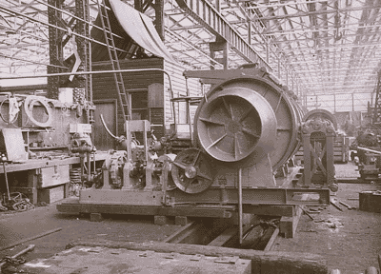

**mine-sweeping winch under construction**

**7. A tough *Act* to follow**

The difficulties faced by Midland’s heritage and higher education precinct planners and campaigners are not all of this general nature. Indeed, some of the most important problems are quite specific and can be found to have their origins in the *Midland Redevelopment Act* (1999) – a statute, ironically, put in place for Midland’s benefit.

The *Act* was the creation of a former conservative State Government. It is essentially an *Act* that authorises land development and disposal and the Midland Redevelopment Authority (MRA), has been structured accord-ingly. Its principal statutory task is to develop and dispose of a former industrial site over a 15 year period – of which 5 years have now elapsed.

Given the problems of the site – contamination and the lack of con-temporary infrastructure - it is hoped that land sale revenues will cover rehabilitation and development costs. Thus the MRA enjoys a $100 million line of credit with the State Gov-ernment to fund these works and it is expected to repay this money with the proceeds of land sales. Together with the lack of its own working capital, this imperative to sell and payback casts a shadow over the MRA’s planning. The demands for expensive heritage building maintenance and re-furbishment (at a possible cost of $50 million) make this situation worse still. Additionally, the MRA Board and Executive were appointed accordingly – to develop and sell off land in the expeditious manner required by the *Act*. How could it be otherwise?

When all of these factors are taken together, it becomes apparent that more imaginative and socially-oriented planning has little chance. Or perhaps there is better way of putting this. While the *Act* presides over the whole of Midland’s redevelopment, imaginative and socially oriented planning are constrained in many ways and supported in just a few. The outcome so far is an MRA concept plan – recently published as ***midland-metro*** - that fails to make optimal use of the whole site, that does not cohere and that will not take Midland into the 21st century as a vibrant, sustainable regional centre or economic driver.

To state the case briefly, ***midland-metro*** commits too much land to economically dead-end uses that discourage street life and degrade urban space – as noted above more bulk goods retail and more light industrial development. It hardly seems credible that anyone, other than the bulk goods retail sector, believes that Midland needs more of these facilities so close to town. Midland is already a bulk goods retail town! In any event, with the exception of police facilities, the entire eastern half of the Workshop Site – some 50 ha of land - is to be effectively given over to these uses. This land, it needs to be stressed, is bounded by the Helena River and a railway line (incorporating a possible future new Bellevue station) and falls within 500 metres of Midland’s town centre.[18]

In the light of these strategic amenities, commitment of the land in question to such a low rent, car-intensive use is astonishing. These are not planning decisions that will help to “revitalise” Midland, as the MRA promises. They will, rather, consign it to second-rate status as a regional centre falling ever further behind its western counterparts. And all of this, again, is the work of the *Midland Redevelopment Act*. And the scene becomes almost tragic when excluded possibilities are considered - a 10,000 student campus on the edge of town**. Again it seems that fateful decisions are in prospect: Midland as a bulk goods retail centre or Midland as a university town?**

It is also worth noting that Friends of Midland City University has put the following questions to the MRA in a recent formal submission:

* How much capacity is the MRA adding to Midland’s existing large format (ie bulk goods) retail capacity and what are the possibilities that it might contribute to an oversupply?
* What are current vacancy rates in this commercial real estate sector in Midland?
* Is appropriately zoned land avail-able for expansion of relevant capacity elsewhere in or around Midland (and not on the town’s very doorstep)?
* How likely is it that new capacity will be occupied by tenants vac-ating space elsewhere in Midland – and not by new tenants – thereby contributing to further blight?
* Might the release of commercially zoned land in the MRA precinct contribute to downward pressures on commercial land values and on the value of adjacent lands de-dicated to other and higher grade uses? (In other words, could the good planning intentions evident on the site’s west be undermined by current plans for the east?)
* What are the likely local traffic, transport and environmental im-pacts?
* What are the likely social impacts and opportunity costs?

The MRA either did not answer these questions or did not answer them adequately.

**Midland’s future as a “phenomenal learning hub” is real only in the exuberant imaginations of two Ministers not attending to alternative advice – or to the dimensions and historic scale of the region’s neglect. Yes, Midland could be so, but not on the basis of the MRA’s planned “community learning centre” encompassing high school and TAFE relocations.**

To be sure, plans for the site’s Western end, including heritage building space, documented in ***midland-metro,*** involve a “community education centre” built largely around high school and TAFE teaching facilities. The presence of this still embryonic centre is largely the work of The Swan Tertiary Education Working Party **(see Box 3).** Early plans, however, contain no provision for a significant university presence now or in the future and cynics have argued that it involves little more than a reshuffling of secondary and TAFE capacity in Midland. On this view, Midland’s “phenomenal learning hub” is real only in the exuberant imaginations of two Ministers not attending to alternative advice – or to the dimensions and historic scale of the region’s neglect.

|  |
| --- |
| **Box 3 The Swan Tertiary Education Working Party**  **The Working Party is the most important official committee involved in planning the Midland Workshop’s future education facilities. It was initiated by the City of Swan in 2002. The City also provides executive support the Working Party. Other participants include:**   * **the Midland Redevelopment Authority (MRA);** * **the Eastern Metropolitan Regional Council;** * **Swan TAFE;** * **Department of Educational Services;** * **Department of Education and Training;** * **Friends of Midland City University;** * **the Swan Chamber of Commerce;** * **Curtin University and the Office of Michelle Roberts MLA.**   **Membership of the Working Party also overlaps very considerably with another important stakeholder group in the future Workshops education precinct: the Department of Education and Training Local Area Planning Committee.** |

**8.** **A suitable piece of real estate**

### What can the State Government do to facilitate the development of serious higher education facilities in Midland? In general terms it simply needs to reduce the levels of uncertainty and the contrived sense of urgency that the *Midland Redevelopment Act* creates. It needs to slow down – and rebalance - a planning process which is dominated by commercial imperatives and which threatens foolish and possibly destructive land use.

### 

### Those making community and public interest claims on the Workshop site should not be required to work in such an environment. Nor should they, while working, be required to suffer the anxieties associated with changing electoral fortunes and political whim in its many forms. That is both destabilising and disrespectful. Indeed, it discourages engagement, disemp-owers community and erodes social capital. In short, it achieves the very opposite of what enlightened social policy today claims as its most important objectives.

### 

Social policy objectives to one side, general decency and values of fair play require that community claims be given a guaranteed and usable stake in the Workshop site. Additionally, the place of the site in WA’s industrial development and labour history - and the losses that Midland suffered when the Workshops closed in 1994 - immeasurably strengthen this claim.

So how can a usable stake in the site be guaranteed?Essentially two things need to done:

* **first**, an appropriate portion of the Workshop site must be securely set aside and decisions here need to be set in the context of sufficiently long term planning horizons. What will Perth’s north-eastern region require in 20 or 30 years time? We plan our roads in more generous time frames than this. Is higher educat-ion less important?
* **second**, the issue of higher edu-cation funding needs to be addressed in a more honest, creative and patient way.

The remainder of this Section of the Report discusses the first of these issues. The second issue is discussed in Section 9.

### Reserving an appropriate site

The most important, most urgent and, luckily, the easiest thing to be done involves setting aside a suitable portion of the Workshop site and dedicating it to the development of a higher education precinct able to acc-ommodate a growing university. And if we can bring our-selves to think 30 years ahead, this should be the whole of the site not yet firmly dedicated to other uses – lets say one of the three major Workshop blocks and all land shown as hatched on ***mud map*** overleaf. (Perhaps some this land will later be swapped for in-town sites; perhaps not. Let the fledging university have a small land bank to give it both solidity and flexibility.) There are various ways in which the land could be set aside and those who founded UWA have provided one model worthy of serious consideration: the *University Endowment Act* of 1904.

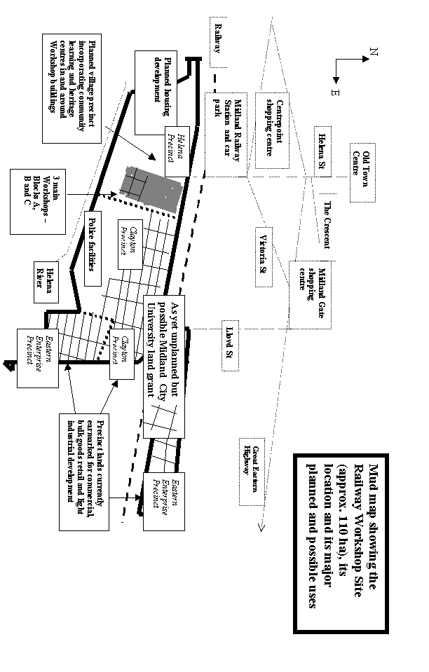

Of course, a Midland endowment on the scale of the 1904 University endowment could not reasonably be expected. But if, hypothetically, the balance of the site to the east of the Helena Precinct was involved together with Block C of the major Workshop buildings – some 40-50ha - this would be less than one fifth of Murdoch’s land grant or roughly equal in size to one half of Curtin’s 80 hectare campus in Bentley. Also its value would almost certainly be less than the value of the Churchlands campus recently granted freehold to Edith Cowan University for the benefit of Perth’s northern suburbs.

How hard his this? Minister Mc-Tiernan could, using the discretionary powers assigned to her by the *Midland Redevelopment Act,* set aside a suitable portion of the site. With the right will and a little creativity, she could also remove this land in some irrevocable way from the destructive wake of an extended land auction favouring lower grade uses. But whether it is done in this or some other way, the reservation and dedication of land should happen soon. It would be a real shot in the arm for local campaigners and planners. It would also provide some real protection against future political change. As things stand, Midland’s community initiatives could still be scuttled; anchored in land, they would become much more durable.

But serious support for higher ed-ucation in Midland would do more. It would show that the State Gov-ernment – whatever side is in power - was motivated by a more expansive sense of community development. It would also demonstrate that the Department of Planning and Infra-structure and its Minister included Midland in their ongoing *Dialogue with City*. For in this *Dialogue*, the conversation often turns to strategic regional centres, to their importance for Perth’s future growth and, using the Minister’s own words, their past “failure to thrive”. In Midland’s case, the development of a serious Higher Education Precinct could well mean the difference between “thriving” and continuing to stagnate. (***See Box below***).

# **Higher education & Midland’s regional economy**

**Today, some $75 million in direct higher education expenditure per annum exits the north-eastern metropolitan region with its 7,500 commuting or relocating university students[19]. This figure could well rise to some $200 million over the next two decades as population and participation rates rise - and this would still be only part of the loss suffered by the Midland regional centre economy and its hinterland. For, along with direct educational spending, goes indirect educational spending - on books, stationary, computers, food, coffee, alcohol, entertainment, clothes, fuel, rent and so on.**

**Official (ie DEST) estimates suggest that losses here could be roughly equal in magnitude to direct higher education investment losses – increasing total regional losses to $400 million pa. Retaining just half of the activity associated with this sum would mean a shot in the arm for Midland and its region worth some $200 million pa – four times the current annual budget of the City of Swan. And along with these losses go a wide range of jobs – jobs scattered across the full employment spectrum and encompassing both high end knowledge economy and more routine service work. Retaining this money and activity could well mean the difference between a “thriving” future for Midland and one of continuing decline.**

Finally, serious support for higher ed-ucation would demonstrate that the State Government, notwithstanding the Commonwealth’s important role in the sector, understands the meaning of its long term strategic planning res-ponsibilities in the field of higher education.

**Patient investment**

To argue for long term planning horizons is not to argue for delay. It is worth restating, however, that the *University Endowment Act* of 1904 was passed some 10 years before UWA came to life as a going university. Those in charge of our fledgling State understood that creating a university was a big undertaking and so they did not try to do it all once. They did it a bit at time – they set aside land in 1904 but did this not knowing quite when or on what scale they would have to start paying out for capital works and, likewise, uncertain about how operational costs would be met. They argued then, too, it is interesting to note, about the fairness of imposing fees on students and the wisdom denying poorer bright students a university education.

**Those in charge of our fledgling State in the early years of the 20th Century understood that creating a university was a big undertaking and so they did not try to do it all once. They did it a bit at time and they set aside land first. They passed the** *University Endowment Act* **in 1904, conferring about 1600 ha of land on UWA some 10 years before it began its life.**

But the most important point here is another one. They did not, on day one, add up every cost, throw their hands in the air and declare that it was all just too hard. They staged the whole exercise and they did the easiest thing first: they set aside land. At that point only two things, apart from the land, were certain: their determination and their good faith - and how much the poorer would we Western Australians be today if they had not set about the work of government in this far-sighted and courageous way? Setting aside land at the Midland Workshop today would be as just easy and would cost no more than the taxes and administrative costs involved in transferring real estate.

**The people of Perth - and WA - were well set up by those who laid the foundations of UWA. The current Government could do the same for Midland now.**

Our State Government today could demonstrate its courage and good faith to the people of the Midland region by firmly setting aside a suitable portion of the Workshop site for future higher education uses. Just as the people of Perth (and WA as a whole) were set up for the following century and beyond by those who laid the foundations of UWA, so, too, could the current Government now put in place the ground work for an institution building process to better provide for the people of north-eastern metropolitan Perth long into the future.

By 2030 the population of this region will certainly reach 500,000 and it could well be home to some 20,000 university students. Should they all be commuting to the City’s western districts for their higher education?

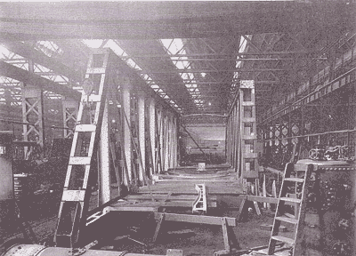

**girder bridge sections for the mt lawley subway under constuction in the mildand railway workshops – below: The finished subway**

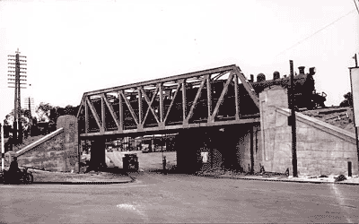

**9. University Funding**

The question of funding for new universities is always a good counter argument: Thus “it costs millions to build universities and millions more each year to keep them going.” Then the lament: “Where is all the money to come from? Perth already has too many universities!” It sounds plausible enough but the case overlooks two important considerations. First university student numbers are growing at a significant rate and second, students can, for a variety reasons, be considered to be self-funding. That is to say, when they come to study at university, they bring their own funds. More students are coming and they are bringing their own funds.[20] There is, in this big picture view, no funding problem. Let’s look at these issues one at a time: sector growth and self-funding students.

### The inevitable growth of higher education

As everywhere in Australia, demand for higher education in WA will grow and this growth will be fuelled by:

* population growth (fed by im-migration if all else is wanting);
* the more demanding skill re-quirements of a competitive know-ledge economy and rising uni-versity participation rates;
* growth in overseas student num-bers.

Overall, growth is inevitable and, indeed, university student numbers could well double in coming decades rising from a current national total of 700,000 to around 1.4 million by 2030 if growth rates prevailing for the past decade continue into the future – see ***Box 5****.[21]* There will, therefore, be a need for new higher education cap-acity. Would any one dispute that Midland and its region can stake a legitimate claim to some of it.As already noted, there are currently 7,500 students in the Midland region and this number could, again, grow to 20,000 in 20-25 year time – if it catches up to average participation rates.

**Domestic university student numbers could double in coming decades – perhaps rising from a current national total of 700,000 to around 1.4 million by 2030. There will, therefore, be a need for lots of new higher education capacity – and there will be very little argument about this. There will be argument, rather, about how much of that capacity students pay for themselves and, more relevant in the present context, argument about where new capacity will be located. Midland should be readying itself now – by setting aside inner urban land.**

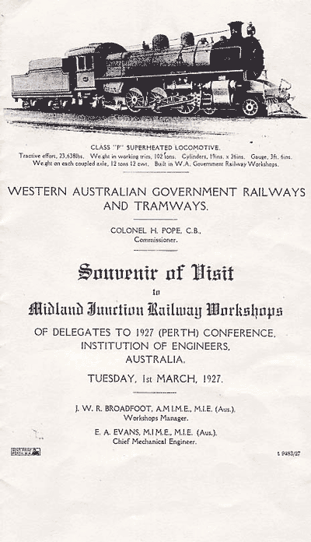

### Box 5 Recent Australian university enrolment trends - including overseas students

**1992 total university students 559,000**

**2002 total university students 835,000**

**Total growth for decade 35%**

**Growth for overseas students for decade 35%**

***The Australian* May 7th 2002**

Self-funding students

University students can be considered as self-funding for two reasons. As in many public service domains under-going rationalisation and “restruct-uring”, university students are in-creasingly considered to be customers who come to university to “buy” their education and degrees. They may be paying with a mixture of their own money, borrowed money or gov-ernment grants but they are buying and they are customers. In other words, again, the money to maintain universities comes with the students. This is so even while governments continue to subsidise university study. It is starkly and unmistakably so when they cease to pay these subsidies and when students must save or borrow to pay the full costs of tuition. Considered within the frame of this bigger picture, the proposition that there is no money is a serious distortion.[22] And the consequences again are two fold: high costs for Midland region students (time, travel costs, inconvenience) and enormous losses to the regional economy.

**Whether they are paying with their own money, borrowed money or government grants, students are coming to university to buy their educations as customers. And the truth now is simply this: students in Midland already have the money necessary to pay for a university in Midland. They are just being denied the opportunity to do so – and forced to travel a long way to do their shopping.**

In the not so distant past it would not have been possible to make so simple a case – for at least two reasons:

* universities relied more sub-stantially on one-off capital grant funds – seriously complicating the unit (per student) cost and cost accounting picture;
* accounting systems and practices were not sufficiently well devel-oped or rigorous to identify the costs associated with providing services to each student.

But, in today’s world of rationalising public service delivery, these things are changing. Government today prefers accurately delivered recurrent funds based on full-cost accounting to the unpredictably and imprecision of *ad hoc* grant funding regimes and so encourages the former at the expense of the latter. The reasons for this include not just precision and pre-dictability but also accountability and performance management.

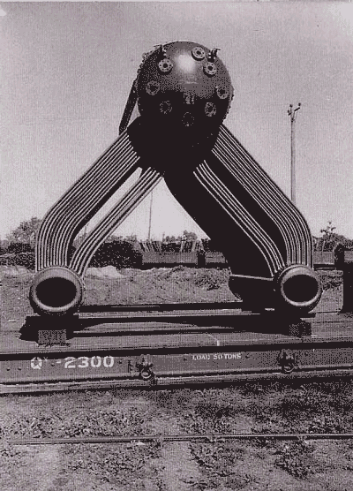

Yarra Boiler for Ran - The Midland Railway Workshops also Contributed Directly to the australian war effort

In the present context, these changes are critically important for another reason as well. They facilitate the integration of the two once entirely separate worlds of private and public sector financing – as the latter adopts the language of the former. Thus universities – even publicly funded universities – can, if they conduct their business and their accounting on a commercial basis, access private sector bankers, financiers and investors for their development and growth needs much more easily. If university planners go to them, knowing what it costs to provide a service, knowing that they can price it competitively and still show a profit, then deals will be done. A new university in Midland could establish itself in this world. Just two further qualifying points.

There are many reasons for feeling uncomfortable with this new world but one can be dispelled easily and quickly. Rational accounting and commercialised funding do not entail privatisation, for that is an entirely separate issue. The changes outlined above mean that government ceases to directly fund **service providers**. Rather, government funds service providers indirectly by funding **service users** – with all or some portion of the cost. It is in this way that customers and a culture of customer service are created. Privatisation proper, on the other hand, involves the absolute withdrawal of government funds – whether directly or indirectly provided.

New rationalised recurrent funding based on full cost recovery will not spell an end to one off capital funding grants - public and private for universities. They will remain important – especially in relation to research. Overall, however, they will become less important. Having said this, a number of funding sources that a developing university in Midland might tap include:

1. Regional centre development funding;
2. Partners in the precinct;
3. Specific purpose development grants; and
4. Smart value-capture

**Regional centre development and educational planning**

It is not impossible that a future Federal or State Government will come forward with metropolitan regional development/investment programs over the next decade - of the kind that assisted both the East Perth and the Subiaco Redevelopment Authorities. Despite attempts to consolidate the city, a recent Government research paper clearly indicates that the bulk of Perth’s future population growth in coming decades will take place in the outer suburbs.*[23]* The same paper also acknowledges that pressures for well-developed regional centres will, as a consequence, only become greater. Eventually both Commonwealth and State Governments will be forced to act. **Meanwhile, strategically valuable sites should not be given over to sub-optimal uses just because that time has not quite come yet.**  It is the capacity to think ahead and to make appropriate decisions here that sets inept Governments apart from intelligent ones – like those that set land aside for UWA a century ago.

**Partners in the precinct**

Innovative approaches to higher education increasingly favour institutional flexibility, fluidity and diversity. This means closer relations and more co-operation between service providers and sectors, easier student movement between them, more cross-enrolment, cross-fertilisation and credit transfers as well as the increased sharing of infrastructure, resources and so on.

Institutional innovation of this kind also brings with it possibilities for system wide economies and funding innovation. A Midland higher ed-ucation precinct established on this more fluid model need not rely on “new” and dedicated university funding alone. Rather, substantial fun-ding could come from existing (or future) specific departmental capital works budgets. Some possibilities are already in an exploratory phase within the Department of Education and Training. They have been referred to above in the context of the MRAs planned community learning centre. Thus a university presence could take DET on as a joint venturer. A range of less orthodox contributors to the community learning centre have also been identified – and could form parts of an even larger integrated whole or precinct (see **Box 6**). This precinct model has been embraced by the Swan Tertiary Education Working Party and, in principal, at least, the idea should be welcomed.

If such a centre is to properly provide for Midland’s educational require-ments in the new century, however, it needs to be built upon or around a planned and substantial university presence. No such presence is currently on anybody’s drawing board. Part-icipants in the planning process speak “off the record” about securing a university presence “by stealth” but this cannot and will not deliver the required results – and it will almost certainly fail to deliver results if no land has been reserved for future university development. Midland, in any event, deserves better than this. It deserves properly planned university facilities which are central, strong and visible – not marginal or meagre or invisible.

**Box 6**

# **The most detailed description of the precinct model is to be found in a report commissioned by the Swan Tertiary Education Working Party. The report[24] identifies and documents the following agencies or organisational forms as potential participants in its favoured precinct model:**

**\* community engagement centres;**

**\* universities (from beyond as well as within WA;**

**\* skill centres;**

**\* research centres;**

**\* business incubators;**

**\* alternative post compulsory learning centres;**

**\* brokerage hubs.**

# **Specific purpose development grants**

From time to time and for specific purposes, both the Commonwealth and State Governments make one-off capital grants to universities. Not surprisingly, these can be very substantial in the early development phases of new universities. While much of the discussion above has involved arguing that funding by these means is becoming less important, it should not be written off. There are still traditional university funding sources and Midland is no less entitled to benefit from them than are other regions. Yes, this may be a bold demand. But it is not a demand for any Treasurer to reach into his or her pocket at short notice. It is a firm but patient request to begin planning for important capital expenditure both well in advance and in manageable steps or stages. The way it should always be done.

**……………………**

To take advantage of funding opp-ortunities of the kinds outlined above, planning authorities in Midland need to do three things:

* immediately cease committing pro-perty, and especially the Work-shop Site, to sub-optimal uses;
* declare alternative and serious long term higher education development intentions; and, as suggested above,
* remain farsighted and patient – to take advantage of both new ideas and new opportunities to fund them as these present themselves.

Point 3 is especially important. If it is innovative and well conceived, the whole project will, over time, attract funding in a variety of forms. Second, the reasons for making funds available will become more socially (and politically) compelling as the State’s growth and need for high level skills outstrips current higher education capacities – as will inevitably happen.

#### Smart value capture

A final possible source of development funds should also be mentioned – the site itself. Could the MRA have underestimated the value of the site? (We have, on the basis of very little information, assumed that the MRA is working on the basis of an estimated value of $100 per square metre.) If this figure is too low, the land represents an undervalued asset here. And if this is, in fact, the case, why not dedicate surplus revenue to constructive capital works purposes – to serious higher education investment in Midland.

Unfortunately, the MRA has denied the author of this Report access to the data and modelling assumptions on which its future land value and revenue projections are based. The inform-ation, it claims, is commercially sensitive. The Minister, however, could order a review of the financial modelling and there is at least one additional (additional to the possibility of routine underestimation) reason for doing this: the value of the site and its abutting lands still in public ownership would increase dramatically if a substantial higher education precinct incorporating a serious university presence was placed at its centre. Original forecasting did not take this properly into account. And we know this because, in the late 1990s, the idea of a substantial university presence on the Workshop site was dismissed as a joke in official planning circles.

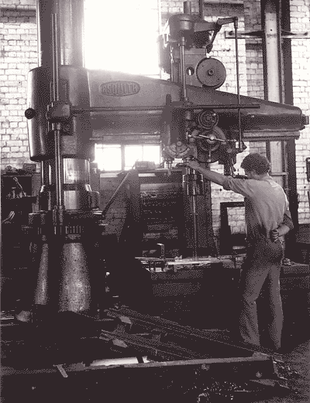

**DRILL PRESS**

This matters for two reasons. It matters because the capital funding required to pay for physical infrastructure could, in part at least, be created by the external benefits generated by the project – provided smart value capture strategies are put in place. How irrational would it be to reject this argument? Sadly, such irrationality is common enough and there are many precedents for the thoughtless sacrifice (or intentional misdirection) of external benefits belonging to taxpaying communities.

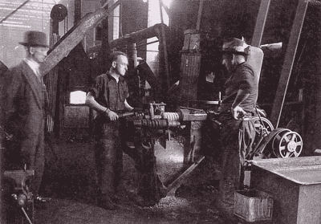

**spring makers**

It also matters because, just as some planned land uses enhance land values in surrounding districts, others can have the opposite effect. Thus it is unclear how the MRA’s decision to commit substantial land to unspecified commercial, large format retail and light industry on the Workshop Site’s eastern side (with huge sterile parking areas) will effect the value of its west end land holdings and projects.

**10.Conclusions**

Perth’s existing universities have shown little interest in Midland’s higher educational future. They do not want to come to Midland – and why should they move east for as long as most students from the Midland region can be forced to bear the costs of commuting or relocating to the west – or even of missing out? As they transform themselves into business entities, universities become less able, as corporate bodies to orient themselves to public interest concerns. This is the less fortunate side of the commercialisation of universities briefly discussed above. Governments however, are not businesses and they remain bound by considerations of public interest and social good.

In the absence of local university interest in Midland, Friends of Midland City University are cam-paigning for a new university - Midland City University. And they will continue to do so while the State’s existing universities remain indifferent. The State Government, however, has more options. It could pressure the State’s existing universities to show a real interest in the Midland region.[25] Taking a wider view, it could also impress upon them the importance of a joint “industry plan” which balanced commercial imperatives against industry-wide social obligations to the people of WA wherever they happen to live.

Ironically, it is Brendan Nelson, Federal Minister for Education in a non-Labor government, who is shaping up as (national) planner here. We do not, of course, welcome most of his rationalising and restructuring aspirat-ions. But his realisation that higher education development now calls for planning horizons beyond those of any individual institution is welcome.

There will be the predictable hue and cry about independence but universities now need to secure their independence in different and more effective ways. They need to so collaboratively, not as a divided rabble in which all imagine themselves to be standing heroically alone – or in beggar-thy-neighbour fashion. They need to understand that they are each a part of a system of higher education – the sum of which is greater than its parts. Having said that, the obligations and requirements of that system and the shape of its intellectual life, will be best defined by the universities themselves acting in concert. Only in this way are they likely to be able to stand firm against partial interest, parochial vision or political whim. Nelson’s initiatives will certainly make for an interesting new chapter in the history of higher education in Australia. But that, of course, is another story.

#### Key recommendations

**The State Government should:**

1. **grant or guarantee** the availability of land sufficient for long term future higher educational – including university - development in Midland. This could mean the balance of the Midland Re-development Authority (MRA) controlled lands in public owner-ship and not contractually com-mitted to other users;
2. **amend** the *Midland Redevelop-ment Act* so that it:

* enshrines commitment to a Midland Higher Education Precinct in legislation;
* gives official recognition to the pre-eminent claims which a higher education precinct has over the Railway Workshop Site and adjoining publicly owned lands under the control of the MRA;
* protects prospective Precinct sites from sub-optimal develop-ments and developments hostile to the above high grade uses;

1. **establish** a new Management Board that brings together expertise and experience relevant to the amended *Act* and includes more direct representation from, herit-age, higher education and post-secondary education sector stake-holders;
2. **direct** the Board, through the *Act*, to develop a 20-25 year strategic redevelopment plan – a plan based on both a clear vision of the region’s future and a well-researched understanding its current cultural and higher ed-ucational development needs;
3. **direct** the Board to develop a strategic plan that

* includes provision for senior high school, technical and uni-versity education;
* includes provision for in-creasing integration between these educational sectors;

1. **direct** the Board to develop a strategic plan integrating heritage, secondary and post-secondary and higher educational uses in order to maximise

* community access and respons-iveness to local needs;
* potential for innovation and creativity;
* institutional cross-fertilisation and synergies;

1. **establish** an expanded and app-ropriately qualified Executive and provide the new Board and Executive with a working budget that recognises the pre-eminently social and public interest character of its charter;
2. **ensure** that current community and education initiatives relating to heritage and higher education take their place within a long term planning framework and dis-courage piecemeal efforts likely to replicate Edith Cowan’s failed higher education experiment on the Railway Workshop Site.
3. **order** a review of the original financial modelling and forecasting conducted by the MRA in order to plan its development and re-development work.
4. **encourage** the State’s existing uni-versities to develop an “industry plan” which incorporates a clear social charter and which refers to the higher educational needs and reasonable expectations of all people in WA – including those living in the Midland region.

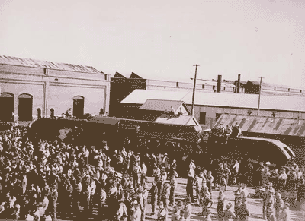

**garett locomotive in background**

1. These places exist as result of an impulsive Ministerial gesture involving Brendan Nelson over a celebrity breakfast hosted by the Swan Chamber of Commerce. The places are un-supported by any long term plan or co-ordinated commitment on the part of the State and Commonwealth Governments. They are currently managed by Curtin University.
2. The lower figure if currently low regional university participation rates (2.8%) continue and the higher if the region catches up with average participation rates in the rest of Perth today (3.9%).
3. $30,00 for full time students but relevant calculations in this Report conservatively assume average actual students to be engaged on a 67% time basis.
4. Figures for the year 2000.
5. By our best rough and ready reckoning. The MRA has refused to provide us with relevant financial information.
6. See MRA’s planning intentions as these are expressed in the recently revised concept plan: ***midlandmetro***.
7. Over and above the unobjectionable police facilities already established on this part of the site.
8. This expression is not original. I know, for example, that it was as used in the title of Des Ball’s book, *A Suitable Piece of Real Estate: American Installations in Australia,* Hale and Iremonger, 1980.
9. Based on the continuation of recent 3% growth rates.
10. Vintila 2001, citizenonline.org Since published in *Urban Policy and Research*, 2003.
11. Vintila 2001
12. Based on regional population projections and average Perth university participation rate.
13. Though recent evidence suggests a quite volatile market.
14. The 1904 *Act* conferred huge tracts of land on the [then] future University of Western Australia.
15. We estimate that the Workshop Site has a forecast (improved) value of $100 psm - the MRA has been extremely unhelpful in providing any hard information concerning the basis of its valuations, calculations and projections.
16. *Midland Reporter*, May 25th 2004.
17. 20 equivalent full time places made available last year and currently administered by Curtin University.
18. Now defined by the alignment of The Crescent and incorporating Midland Gate.
19. Assuming a conservative average of $15,000 pa per full-time student for tuition costs – and discounted by one-third to establish EFTSU.
20. The source of these funds will be discussed in a moment.
21. See also *Higher Education: Report for the 2004 to 2006 Triennium*, Minister for Education, Science and Training.
22. It is true that the Commonwealth appears to be providing government supported places at only about half the rate of growth noted above. But it is at the same allowing and facilitating an increasing number of fully private places. See again, *Higher Education: Report for the 2004 to 2006 Triennium*, Minister for Education, Science and Training.
23. *Dialogue with the City*,Issues Paper, Department of Infrastructure and Planning, WA, 2004.
24. The report – *Midland Education Precinct: Models for the Delivery of Tertiary Education Services* - was prepared by the AAAJ Consulting Group in 2003.
25. State Governments have more than moral leverage and authority. As Commonwealth contributions to universities have declined, state government contributions have been increasing. There are also the possible implications of a less regulated higher education environments to consider. In this future world, many of the Midland region’s 20,000 students 20 years hence could well become the customers of an enterprising overseas university. The State Government needs to make sure that everyone understands that we are living on the threshold of this brave new world.